INTERNATIONAL WEB TECHNOLOGY COMPETITION
RAWAN (Ruang Antisipasi Waspada Anak Nusantara)

 | 

Prepared by:
Fitrya Chalifatus Zahro | D4 Manajemen Informatika
Tegar Eka Pambudi El Akhsan | D4 Manajemen Informatika
El Syifa Sawitri | D4 Manajemen Informatika

Academic Advisor:
Binti Kholifah, S.Kom., M.Tr.Kom.

FACULTY OF VOCATIONAL STUDIES
UNIVERSITAS NEGERI SURABAYA
INDONESIA
2026

Project Title:
RAWAN: Interactive 3D Web-Based Platform for Disaster Education Among Indonesian Youth
GitHub Repository: https://github.com/TegarAkhsan/Rawan
Live Demo: https://drive.google.com/drive/folders/1SX6Vf0N-v3EhZbfSSv5313IC_eNIubxF

Team Information
Institution: Universitas Negeri Surabaya (UNESA)
Study Program: D4 Informatics Management
Name | Program Studi
Fitrya Chalifatus Zahro | Informatics Management
Tegar Eka Pambudi El Akhsan | Informatics Management
El Syifa Sawitri | Informatics Management

Academic Advisor | Binti Kholifah, S.Kom., M.Tr.Kom
Institution | State University of Surabaya

Background & Problem Context
As an archipelagic nation situated at the convergence of three major tectonic plates (Indo-Australian, Eurasian, and Pacific), Indonesia requires robust, equitable disaster preparedness systems. Earthquakes, floods, volcanic eruptions, and tsunamis consistently represent the most frequent and devastating hazards in the country (BNPB). Children remain among the most vulnerable demographic due to cognitive limitations in assessing acute risks and performing autonomous evacuations (Ronoh, Gaillard, & Marlowe, 2015), underscoring the necessity of early, experiential disaster education.
Despite disaster mitigation being integrated into Indonesia's national curriculum, implementation remains highly disparate across schools and regions. Existing instructional media printed modules, static infographics, and conventional lectures are text-heavy and abstract, failing to convey the physical, sensory reality of natural disasters; understanding 'liquefaction' from a textbook differs profoundly from observing the mechanical process in real-time. This pedagogical gap between abstract instruction and experiential comprehension is well-documented across primary and junior secondary education, where interactive, concrete visual tools substantially enhance engagement and long-term knowledge retention.
BNPB telemetry underscores this urgency: in 2023 alone, over 3,500 disaster events were recorded across Indonesia, dominated by hydrometeorological phenomena, earthquakes, and volcanic eruptions (BNPB, 2024).
Simultaneously, the maturity of modern web technologies unlocks viable solutions: real-time 3D rendering via Three.js and React Three Fiber runs natively within standard web browsers without requiring software installation or high-end graphics hardware. This creates an accessible, highly scalable delivery vector capable of reaching schools across diverse socioeconomic landscapes, including resource-constrained regions.
RAWAN directly addresses this critical challenge: overcoming low youth disaster preparedness by leveraging browser-based interactive 3D simulation technology.

Problem Identification
    - Disaster literacy gap among children.
Primary and junior high school students exhibit substantial gaps in understanding core disaster mechanisms and executing appropriate emergency protocols. Students must comprehend cause-and-effect dynamics, hazard characteristics, and actionable safety protocols beyond superficial disaster identification.
    - Instructional media lacks experiential interactivity.
Disaster education remains predominantly reliant on static posters, PDF booklets, and lectures. While informative, these media lack simulational affordances that allow learners to observe physical dynamics and practice decision-making. Mayer's (2009) cognitive theory of multimedia learning demonstrates that integrating complementary visual and verbal channels significantly boosts cognitive retention.
    - Inconsistent disaster education delivery across schools.
The execution of Disaster Risk Reduction (DRR) education varies widely based on teacher preparedness and local infrastructure. Amri et al. (2017) highlighted structural inconsistencies across Indonesian schools, emphasizing the need for standardized, self-contained interactive media.
    - Limited accessibility to high-end simulation media.
Immersive alternatives such as Virtual Reality (VR) headsets or native desktop software demand high capital investments, complex installations, and dedicated hardware rarely accessible in Indonesian public schools.
    - Fragmented, single-hazard instructional coverage.
Existing educational tools typically focus on isolated hazard types, requiring students to navigate disconnected applications. Indonesia's multi-hazard geography necessitates a unified platform encompassing earthquakes, tsunamis, volcanic eruptions, floods, landslides, and tornadoes within a single cohesive experience.

Proposed Solution
RAWAN is a lightweight, zero-install web-based disaster education platform tailored for primary and junior high school students (ages 7–15). It replaces static texts with interactive, decision-driven 3D simulations paired with age-appropriate scientific explanations. The functional prototype is fully implemented and accessible in the team's GitHub repository.
The platform centers on Indonesia's most critical disaster hazards: Earthquakes, Floods, Volcanic Eruptions, and Tsunamis, alongside extended modules for Landslides and Tornadoes as proof of modular scalability.
For each disaster type, users enter an immersive 3D scene (classroom, coastline, volcanic slope) and navigate branching decision-making scenarios: choosing actions, receiving immediate visual/textual feedback with scientific explanations, and earning XP before advancing through sequential disaster stages.
The platform operates as a client-side Single Page Application (SPA) without requiring a backend server for its core learning experience:
- User Interface: React 18 + TypeScript, built with Vite and styled with Tailwind CSS.
- 3D Graphics Engine: Three.js via React Three Fiber and @react-three/drei.
- Supporting Tooling: lucide-react (icons) and canvas-confetti (celebratory feedback).
- User data (XP, sound/accessibility settings) persists locally via localStorage with zero student personal data collection.
Each disaster module follows a uniform three-tier learning cycle: Learn (causes, precursors, impacts, emergency protocols, and real Indonesian case studies), Simulate (3D decision arena), and Test (gamified multi-tier assessment).

Project Objectives
- Enhance disaster literacy among Indonesian children aged 7–15 by conveying the causes, mechanisms, and impacts of disasters via interactive 3D simulations.
- Provide educators with a free, browser-based, zero-installation teaching tool compatible with existing curricula without requiring specialized hardware or accounts.
- Improve knowledge retention of safety protocols before, during, and after disasters by having students actively practice critical decisions in simulation scenarios.
- Demonstrate a scalable, low-infrastructure disaster education model easily extensible to additional hazards and regions, as proven by the added landslide and tornado modules.
- Quantify learning engagement and progress through built-in XP scoring, quizzes, and module completions visible to both learners and teachers.

Target Audience
Primary Users
- Primary school students (ages 7–12), representing the core audience for simplified visual explanations and guided decision scenarios.
- Junior high school students (ages 12–15), who engage with deeper scientific mechanisms, geological fault maps, and advanced quiz difficulty tiers.
Secondary Users & Stakeholders
- Teachers, utilizing RAWAN as an instructional aid during Disaster Risk Reduction sessions, classroom drills, or standard Science/Social Studies classes.
- Parents and guardians in high-risk zones, reinforcing disaster readiness at home using practical tools like the 72-hour emergency checklist.
- Schools, regional education departments, and BPBD agencies as prospective distribution partners for wide-scale regional adoption.
Priority geographic areas naturally encompass regions with high exposure to acute hazards such as seismic zones across Sumatra, Java, and Sulawesi, flood-prone urban basins, and active volcanic vicinities mapped within the platform's geoportal.

Key Features
- Interactive 3D disaster simulations: 4 core modules (earthquake, flood, volcano eruption, tsunami) featuring fully rendered 3D environments with branching decision logic, tailored camera views, and real-time XP rewards. Landslide and tornado modules are also fully functional.
- Curriculum-aligned educational content for each disaster covering geological causes, warning signs, physical impacts, emergency protocols, and historical Indonesian case studies (e.g., the 2018 Palu earthquake/liquefaction) alongside official BNPB emergency contacts.
- Gamified quiz system: Question banks categorized into three difficulty tiers (Easy, Medium, Hard), awarding XP and granting the 'Disaster Preparedness Cadre' achievement badge.
- Interactive Indonesian hazard geoportal: Geospatial views of megathrust subduction zones, active fault lines, and active volcanoes (Merapi, Sinabung, Krakatoa) with live BMKG earthquake feeds and risk metrics.
- 72-Hour emergency supply checklist: Modeled after standard BNPB 72-hour emergency bags, categorized by basic necessities, first aid, lighting/communication, and essential document protection with automated weight calculations.
- Accessibility suite: Dynamic font sizing, High Contrast mode, Reduced Motion toggling for vestibular sensitivity, and Indonesian Web Speech API text-to-speech voice narration.
- Procedural sound design: Real-time procedural ambient audio (earthquake rumble, tsunami wave swell, volcano detonation, tornado howling) and interface feedback synthesized via Web Audio API, complemented by confetti celebration effects.
- Anonymous local progress tracking: User XP and preferences persist in localStorage without user accounts or PII data collection.

SDGs Alignment
Proyek ini selaras utamanya dengan tujuan berikut:
- SDG 4 (Quality Education Target 4.7): Equips learners with essential disaster risk reduction knowledge and adaptive skills through accessible, engaging digital learning.
- SDG 11 (Sustainable Cities and Communities Targets 11.5 & 11.b): Fosters long-term community resilience by cultivating disaster-prepared households starting from youth education.
- SDG 13 (Climate Action Target 13.3): Builds capacity for hydrometeorological hazard mitigation, flood preparedness, and climate-adaptive behaviors.
Secondary alignment with SDG 3 (Good Health and Well-Being Target 3.d) through early risk reduction, casualty prevention, and injury mitigation during disaster events.

Innovation & Comparative Analysis
To clearly illustrate RAWAN's unique market position, the table below compares it against standard disaster education approaches in Indonesia:

Dimension | Printed Modules / Posters (BNPB) | InaRISK Personal (BNPB) | Educational Videos / Animations | RAWAN Platform
Format | Static text & illustrations | Risk maps & regional static data | Linear passive video | Interactive 3D decision-driven simulations
Interactivity | None | Low (location query only) | Passive observation | High (active decisions with direct consequences & XP)
Installation / Account | No (physical distribution) | Yes (mobile app + account) | Platform dependent | No (runs instantly in standard browser)
Disaster Coverage | Typically 1 hazard per leaflet | Multi-hazard regional risk overview | Typically 1 hazard per video | 6 unified disaster modules in 1 platform
Accessibility Suite | None | Limited | Rarely available | Built-in (Font scaling, High Contrast, TTS, Reduced Motion)
Marginal User Cost | High reprinting costs | Free, requires smartphone & storage | Free, bandwidth heavy | Zero (instant client-side web execution)
This matrix demonstrates that the combination of decision-based 3D simulation + multi-hazard coverage + zero-install web access + built-in accessibility is uniquely pioneered by RAWAN in Indonesia.
Literature on serious games and digital simulations for disaster education highlights key gaps addressed by RAWAN:
Literature Gap | Key Academic Finding | Implication for RAWAN
Single-Hazard Dominance | Most gamified disaster apps focus on single hazards at household scale. Comparative multi-hazard tools remain scarce. | RAWAN integrates 6 major disaster types within a unified single-page platform.
Low Public Accessibility | Gamified educational prototypes for children often stall at academic research stages without public accessibility. | RAWAN is free, zero-install, and web-based for direct adoption in public schools.
Hardware Barriers of VR/AR | Immersive VR disaster games require costly headset hardware rarely available in developing public schools. | RAWAN uses lightweight browser-based WebGL 3D instead of VR to bypass hardware barriers.
Passive / Single-Player Limits | Most serious games rely on single-player instruction, omitting collaborative group evacuation dynamics. | Acknowledged as an intentional scope boundary; collaborative multi-user simulations represent future roadmap work.
Efficacy of Decision Simulations | Serious games achieve highest retention when integrated into curricula using constructive, decision-driven exploration. | Affirms the pedagogical validity of RAWAN's Learn-Simulate-Test model for active emergency response training.
Kesenjangan dari Literatur | Temuan Singkat | Implikasi bagi RAWAN
RAWAN's core novelty lies in uniting multi-hazard simulation, zero-install web architecture, consequence-driven decision loops, and baked-in accessibility within a single cohesive platform.
Amri et al. (2017) observed that Indonesian disaster education remains dominated by one-way instruction with minimal decision-based interactive simulation. RAWAN directly resolves this literature-identified gap.
Selecting browser-based 3D (over native apps or VR) stems from rigorous field analysis: Indonesian public schools frequently operate on constrained hardware and bandwidth. Web 3D via Three.js runs reliably across mid-to-low-tier hardware without requiring installation, ensuring realistic reach nationwide.
Unlike conceptual proposals, all highlighted innovations are fully realized in a functioning, publicly verifiable prototype available on GitHub and the live demo.

Impact Potential

Educational Impact
RAWAN enhances disaster literacy through interactive simulation and decision-making. Students understand what, when, and why specific protective actions are necessary, bridging theoretical knowledge with practical simulational execution.

Impact on Preparedness
RAWAN strengthens emergency readiness by placing students in consequence-driven decision scenarios with immediate feedback, reinforcing reflex memory for real emergencies as an educational supplement.

Accessibility, Reach, and Scalability
Operating directly in the browser with zero installation or login requirements eliminates access friction. Client-side execution ensures near-zero marginal cost per additional user.

Content and Technology Scalability
RAWAN leverages a modular architecture following the Learn-Simulate-Test paradigm across all modules, allowing effortless expansion to new disaster types and languages without refactoring core systems.

Sustainability and Replicability
Sustainability is anchored by lightweight client-side architecture and an open-source codebase on GitHub. Operating costs remain minimal (static hosting only), ensuring the platform remains free indefinitely.

Impact Potential Jangka Panjang
Over the long term, repeated integration of RAWAN in school curricula will systematically build resilient youth disaster reflexes across Indonesia.

Limitations and Impact Validation
While initial functional testing has been successfully completed, broader empirical validation with diverse student cohorts via pre/post-tests and retention studies remains the immediate roadmap objective.

Key Performance Indicators (KPIs)
To ensure objective impact measurement, the following key performance indicators are monitored:
- Knowledge Score Improvement: Pre-test vs. post-test differential analysis.
- Decision Accuracy: Percentage of correct protective actions chosen in scenarios.
- Knowledge Retention: Longitudinal assessment after 30 and 60-day intervals.
- Completion Rate: Percentage of learners completing full 7-stage disaster modules.
- User Engagement: Average session duration and voluntary quiz replay frequency.
- Implementation Reach: Number of participating schools and classrooms.
- Qualitative Feedback: Teacher and student evaluations of pedagogical clarity.
In the initial stage of implementation, the priority indicators are the improvement of knowledge scores, the accuracy of decision-making, and the completion rate of modules. Other indicators can be used to evaluate the sustainability and expansion of platform usage. With this approach, the impact of RAWAN is not only expressed in the form of claims but is aimed to be measurable, validated, and continuously developed.

Development Methodology
The project followed an Agile sprint-based development model. All 6 disaster simulation modules, the quiz engine, hazard geoportal, emergency checklist, and accessibility suite are fully functional.
Phase 1: Planning and Instructional Design
- Defined user interaction models, core feature set, and instructional content hierarchies.
- Researched and validated scientific disaster mechanisms based on BNPB standards and real Indonesian case studies.
- Established visual language, color tokens, and 3D environment concepts for each disaster type.
Phase 2: Core Engineering and 3D Asset Development
- Configured project architecture using React 18, TypeScript, Vite, Three.js, React Three Fiber, drei, and Tailwind CSS.
- Engineered 3D scene engine and branching decision state machine across all 6 disaster modules.
- Implemented curriculum content, gamified XP/badge quiz engine, interactive geoportal, checklist, and accessibility features.
- Built and refined the Earthquake module first as the reference design template before replicating the architecture across the remaining modules.
Phase 3: System Integration and Verification Testing
- Integrated all modules into a unified single-page platform with consistent navigation and HUD overlay patterns.
- Executed black-box functional verification across all decision scenarios, quiz scoring, local storage persistence, and sound generation.
Testing verified actual outputs against expected behavior, confirming a 100% Pass rate across all primary user journeys.
No. | Module / Feature | Test Scenario | Expected Result | Actual Result | Status
1 | Earthquake Module | Select classroom protective action during tremor | Feedback shown and XP awarded for correct choice | As expected | Pass
2 | Flood Module | Navigate evacuation route in flood zone | Decision branch, feedback, and XP function properly | As expected | Pass
3 | Volcano Eruption Module | Choose mountain slope evacuation path | 3D camera adjusts view and safety feedback displays | As expected | Pass
4 | Tsunami Module | Select coastal response after early warning | Scenario progresses and scientific explanation appears | As expected | Pass
5 | Landslide Module | Navigate lateral escape decision scenario | Module follows Learn-Simulate-Test structure | As expected | Pass
6 | Tornado Module | Execute indoor safe-room sheltering decision | Module follows Learn-Simulate-Test structure | As expected | Pass
7 | Gamified Quiz System | Complete quizzes across 3 difficulty tiers | XP increments correctly and Cadre badge unlocks at target | As expected | Pass
8 | Hazard Geoportal Map | Select fault line / volcano coordinate marker | Risk level and geological background display | As expected | Pass
9 | Emergency Kit Checklist | Check items across supply categories | Checklist persists and total weight computes automatically | As expected | Pass
10 | Progress Persistence | Close and reopen browser after completing module | XP and settings remain stored without login requirement | As expected | Pass
11 | Typography & Contrast | Toggle High Contrast mode and font scale | UI adapts seamlessly without layout overflow | As expected | Pass
12 | Reduced Motion Mode | Enable reduced motion toggle | Camera animations and particle shake subdued | As expected | Pass
13 | Speech Narration | Trigger voice narration on Learn tab | Browser vocalizes module text in Indonesian via Web Speech API | As expected | Pass

- Conducted cross-browser and multi-screen responsiveness testing across desktop, tablet, and mobile devices.

No. | Device / Browser | Screen Resolution | 3D Rendering Performance | Navigation & UI Result | Status
1 | Google Chrome – Desktop | 1920×1080 | 3D scenes and textures render optimally | Responsive navigation and scenarios | Pass
2 | Mozilla Firefox – Desktop | 1920×1080 | Smooth WebGL 3D execution | All features accessible normally | Pass
3 | Microsoft Edge – Desktop | 1366×768 | Stable frame rate without noticeable lag | Menus and quizzes operate smoothly | Pass
4 | Google Chrome – Android | 360×800 | 3D viewport adapts to mobile dimensions | Touch-friendly controls and buttons | Pass
5 | Safari – iOS | 390×844 | Smooth rendering with safe-area insets | Core navigation fully operable | Pass
6 | Chrome – Tablet | 800×1280 | Layout adapts to tablet breakpoint | Checklist and geoportal clearly readable | Pass

- Conducted preliminary usability testing with sample students and teachers, confirming intuitive navigation and high engagement.

No. | Respondent | Assigned Task | Completion Time | Observations | Feedback
1 | Grade 5 Elementary Student | Complete Earthquake module and quiz | ~10 mins | Benefited from visual explanations before answering | Engaging and easy to follow
2 | Grade 8 Junior High Student | Complete Tsunami module and emergency checklist | ~8 mins | Navigated scenarios smoothly without assistance | Very informative and visually clear
3 | Science / Social Studies Teacher | Evaluate platform as classroom teaching aid | ~4 mins | Praised 3D stages and interactive decision points | Excellent instructional tool for schools

Phase 4: Polish, Optimization, and Final Submission Prep
- Completed bug fixing, asset compression, and performance profiling for resource-constrained connections.
- Completed GitHub repository documentation including README, Installation guide, Technology stack, and Technical specifications.
- Prepared hosted live demo, deployment artifacts, and final proposal submission materials.
The main tools that have been used are React, TypeScript, Vite, Three.js, React Three Fiber, drei, Tailwind CSS, lucide-react, and canvas-confetti, along with Git/GitHub for version control and existing team testing and documentation tools, such as Postman or Swagger for API documentation if needed.

References
Badan Nasional Penanggulangan Bencana (BNPB). (2024). Data Informasi Bencana Indonesia (DIBI). https://dibi.bnpb.go.id
Badan Nasional Penanggulangan Bencana (BNPB). (2023). Panduan Tas Siaga Bencana. https://bnpb.go.id
Badan Nasional Penanggulangan Bencana (BNPB). Nomor Kontak Darurat Bencana Nasional. https://bnpb.go.id/kontak
Badan Meteorologi, Klimatologi, dan Geofisika (BMKG). Peta Zona Megathrust dan Sesar Aktif Indonesia. https://bmkg.go.id
Pusat Vulkanologi dan Mitigasi Bencana Geologi (PVMBG). Status Aktivitas Gunung Berapi Indonesia (Merapi, Sinabung). https://vsi.esdm.go.id
National Research Council/USGS Report. (2019). The 2018 Palu Earthquake and Tsunami: Liquefaction and Landslide Impacts. U.S. Geological Survey.
Sassa, S., & Takagawa, T. (2019). Liquefied gravity flow-induced tsunami: First evidence and comparison from the 2018 Indonesia Sulawesi earthquake and tsunami disasters. Landslides, 16, 195–200.
Ronoh, S., Gaillard, J.C., & Marlowe, J. (2015). Children with disabilities and disaster risk reduction: A review. International Journal of Disaster Risk Science, 6(1), 38–48.
Shiwaku, K., & Fernandez, G. (2011). Roles of school in disaster education. In Disaster Education (Community, Environment and Disaster Risk Management, Vol. 7), Emerald Group Publishing.
Amri, A., Bird, D.K., Ronan, K., Haynes, K., & Towers, B. (2017). Disaster risk reduction education in Indonesia: challenges and recommendations for scaling up. Natural Hazards and Earth System Sciences, 17(4), 595–612.
Mayer, R.E. (2009). Multimedia Learning (2nd ed.). Cambridge University Press.
United Nations. (2015). Transforming Our World: The 2030 Agenda for Sustainable Development (SDGs 4, 11, 13). https://sdgs.un.org/2030agenda
UNDRR (United Nations Office for Disaster Risk Reduction). (2015). Sendai Framework for Disaster Risk Reduction 2015–2030. https://www.undrr.org/publication/sendai-framework-disaster-risk-reduction-2015-2030
React Documentation. Meta Open Source. https://react.dev
Three.js Documentation. https://threejs.org/docs
React Three Fiber Documentation (Poimandres). https://docs.pmnd.rs/react-three-fiber
drei Documentation (Poimandres). https://github.com/pmndrs/drei
Vite Documentation. https://vitejs.dev
Tailwind CSS Documentation. https://tailwindcss.com/docs
MDN Web Docs. Web Speech API. https://developer.mozilla.org/en-US/docs/Web/API/Web_Speech_API dasar teknis fitur narasi suara/aksesibilitas.

APPENDIX I: STATEMENT OF WORK ORIGINALITY
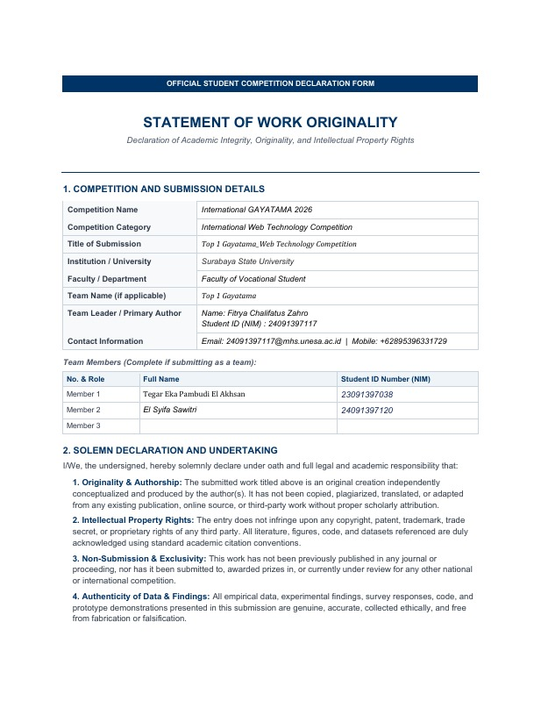

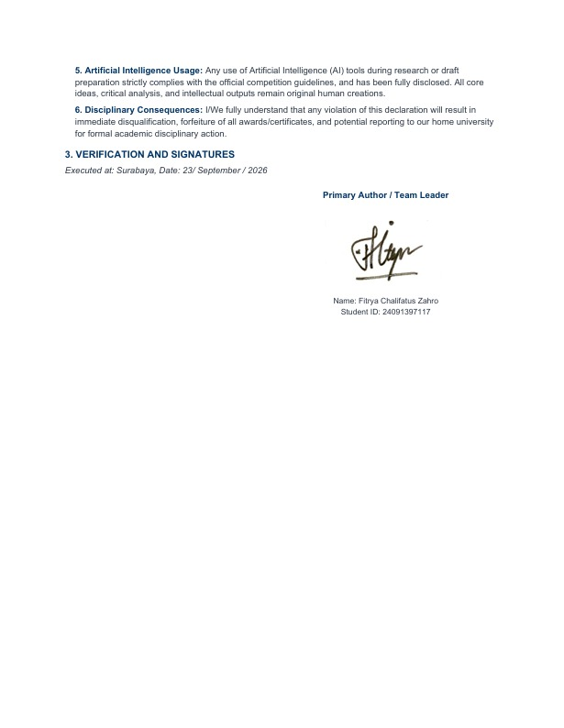

APPENDIX 2: PLATFORM USER INTERFACE SHOWCASE
